Infosys Springboard Virtual Internship

“Project Name: Automated Python Docstring Generator”

Milestone 1: - AST-Based Parsing and Baseline Docstring Analysis

Name: Shreya BJ
Date: 07 January, 2026

Milestone 1:- AST-Based Parsing and Baseline Docstring Analysis

Introduction

Software documentation plays a crucial role in improving code readability, maintainability, and collaboration. In Python projects, docstrings are the standard way to document modules, classes, functions, and methods. However, many real-world Python codebases lack proper docstrings or follow inconsistent documentation styles, which increases onboarding time and maintenance effort.

The Automated Python Docstring Generator & Validator project aims to address this problem by building a tool that automatically analyzes Python source code and identifies missing or incomplete docstrings. The system uses Python’s Abstract Syntax Tree (AST) to understand the structure of the code and applies rule-based Natural Language Processing (NLP) techniques to assist in documentation generation and validation.
This milestone focuses on code parsing, docstring detection, and documentation cover

Objectives
The main objectives achieved in this milestone are:
1. Code Structure Analysis
- Parsed Python .py files using the AST module.
- Identified code components such as modules, classes, functions, and methods.
- Differentiated between script-style files and library-style code.

2. Docstring Detection & Validation
- Checked the presence of docstrings for:
  - Module level
  - Class definitions
  - Function and method definitions
- Flagged missing docstrings accurately using AST traversal.
- Followed Python documentation conventions (PEP 257).

3. Documentation Coverage Reporting
- Generated structured reports listing undocumented classes and functions.
- Identified files where only module-level documentation applies.
- Prepared the system for future coverage percentage calculations.

4. User-Friendly Frontend
- Developed a Streamlit-based UI for uploading Python files.
- Displayed clear feedback on missing docstrings.
- Ensured the tool can be used by beginners without command-line interaction.

Code Implementation
The project is implemented entirely in Python and is divided into logical components for clarity and scalability.

Module 1: AST Parser & Analyzer
This module parses Python source code using the ast library. It traverses the syntax tree to detect module, class, and function definitions and checks whether corresponding docstrings exist. The parser ensures accurate structural understanding without executing the code.

Module 2: Docstring Validation Engine
This component validates docstrings using AST utilities such as ast.get_docstring(). It detects missing documentation and categorizes results into module-level, class-level, and function-level gaps.

Module 3: NLP Utilities (Rule-Based)
Basic NLP techniques using spaCy/NLTK are prepared to interpret identifiers such as function and parameter names. This module supports human-readable description generation in later milestones while remaining fully offline and deterministic.

Module 4: Streamlit Frontend
The frontend provides an interactive interface where users can upload Python files and instantly view docstring analysis results. This improves usability and allows easy demonstration of the project.

/docstring_generator.py
from .ast_parser import parse_code
from .nlp_utils import humanize_name
from .formatter import format_docstring

def generate_docstrings(code, style):
functions = parse_code(code)
lines = code.split("\n")
output = []

for line in lines:
output.append(line)
for func in functions:
if f"def {func['name']}" in line:
description = humanize_name(func["name"])
docstring = format_docstring(func, description, style)
output.append(docstring)

return "\n".join(output)

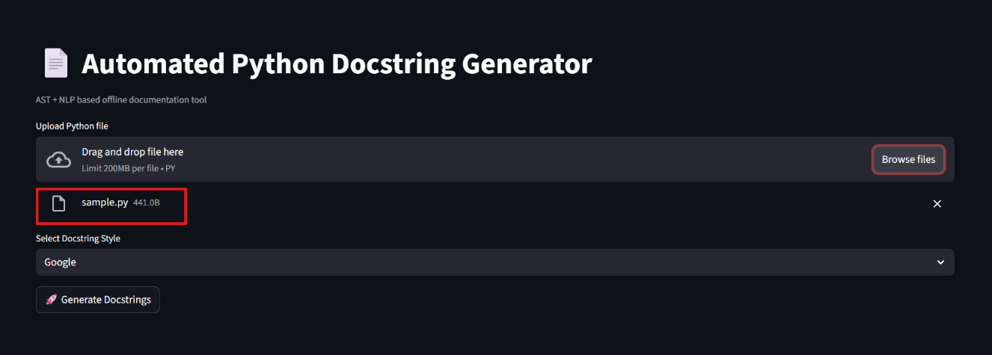
Output Screenshots:

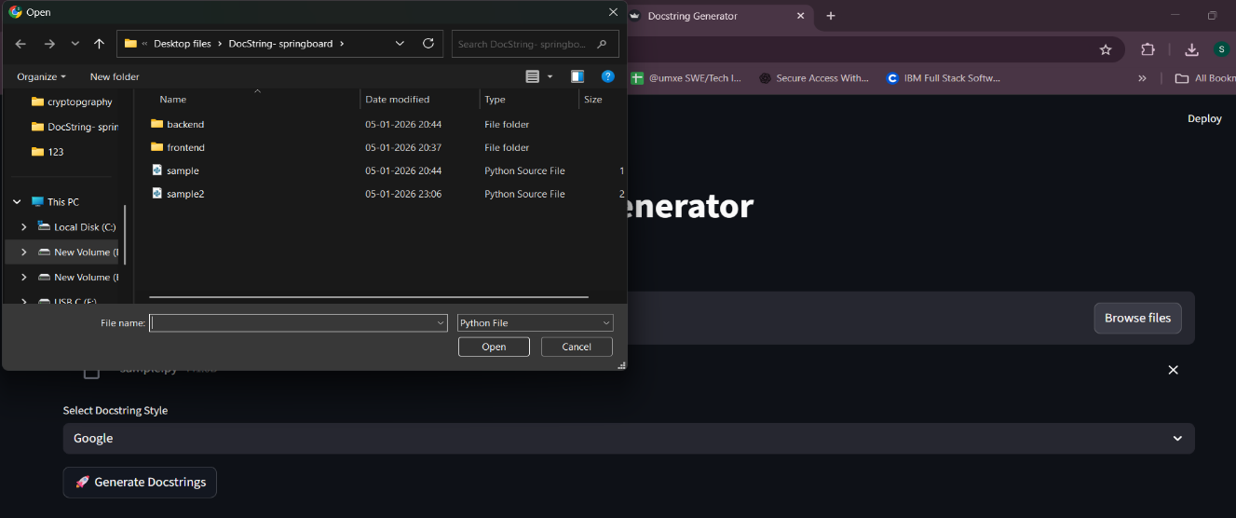

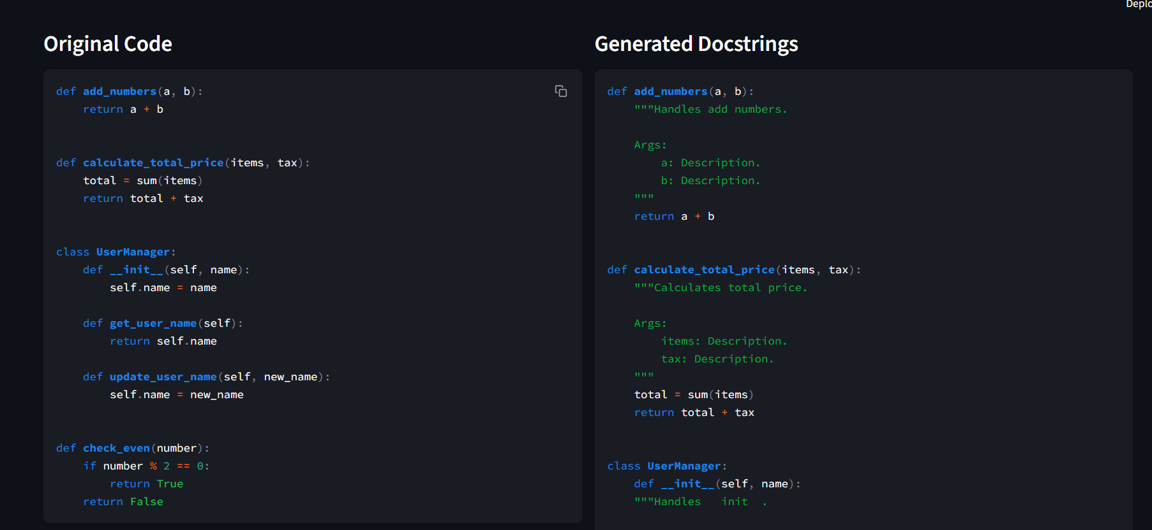
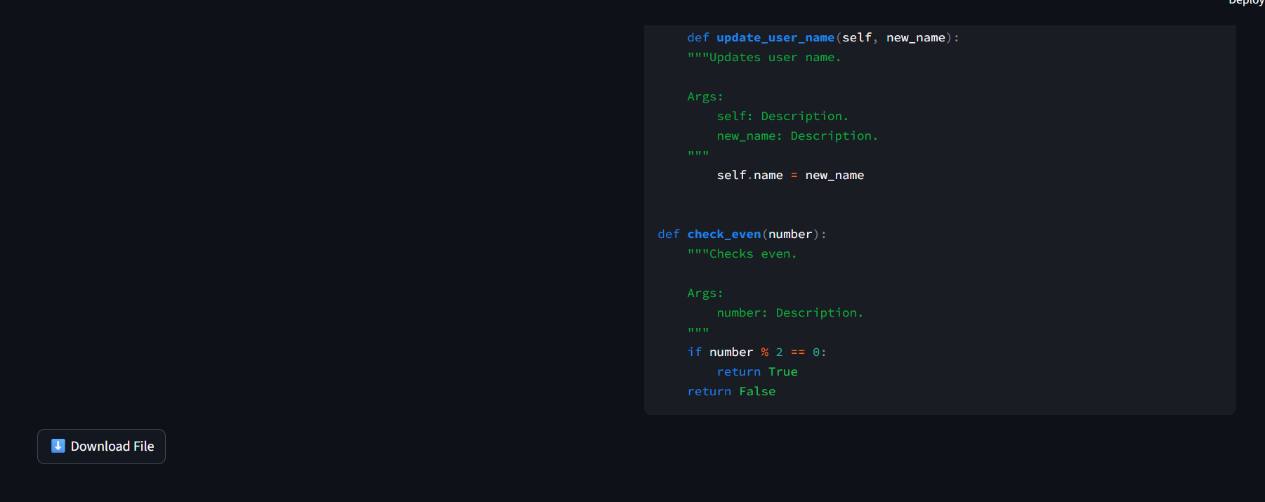
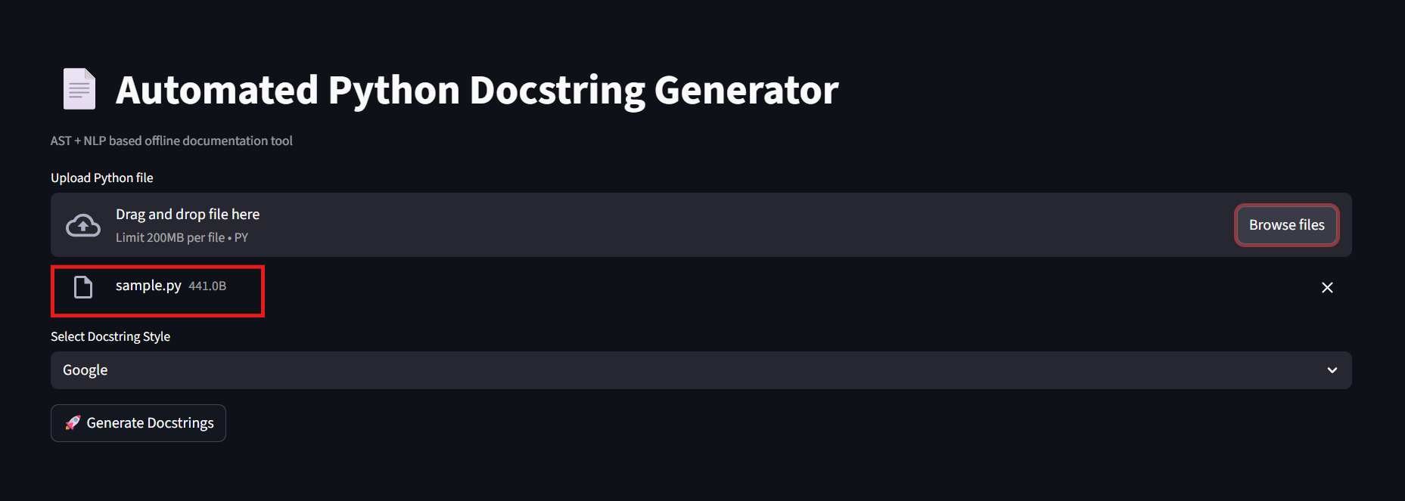

Conclusion

In this milestone, we successfully developed the foundational components of the Automated Python Docstring Generator & Validator. The system accurately analyzes Python code using AST, detects missing docstrings, and presents results through a clean and interactive Streamlit interface.

Key achievements include:

- Reliable detection of undocumented modules, classes, and functions.
- Clear differentiation between script-based files and function-based modules.
- Fully offline implementation using standard Python libraries.
- A scalable architecture ready for automated docstring generation and formatting in future milestones.

This milestone establishes a strong base for extending the project toward automatic docstring generation, style enforcement (Google, NumPy, reST), and CI/CD integration in subsequent phases.

The integration of a Streamlit-based frontend further enhances usability by providing an intuitive interface for uploading Python files, checking documentation coverage, and previewing results. This makes the tool accessible even to beginners who may not be comfortable with command-line tools, while still being powerful enough for experienced developers.
Overall, this milestone establishes a strong and scalable foundation for automated documentation workflows. The system is well-structured, modular, and extensible, enabling future enhancements such as automatic docstring insertion, coverage percentage reporting, CI/CD integration, and style enforcement. The project demonstrates practical application of AST parsing and NLP in real-world software engineering, aligning well with industry standards and best practices.

